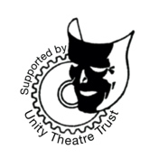
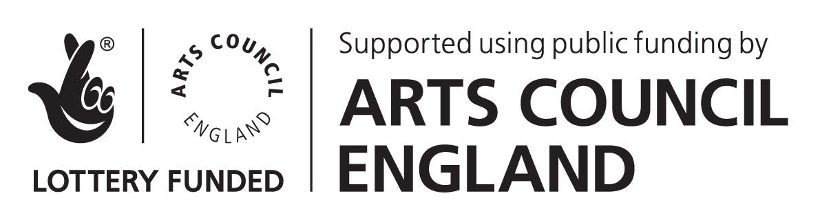
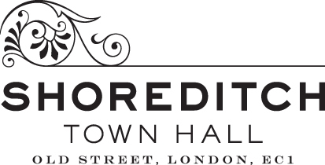
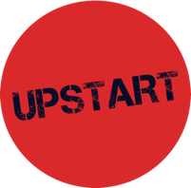

DARE FESTIVAL 5 APPLICATION FORM
Please note that this document is for drafting purposes only. All applications must be submitted via the online form.
We recommend preparing your application offline before submitting it as there is no option to save your work in the form. Before applying, please read through the guidance which is available on our website in standard, large print and audio formats.
Upstart Theatre are committed to making our projects accessible. If you have any access needs, or would like to submit your application in a different format, please contact Producer Hannah Tookey at hannah.tookey@upstart-theatre.co.uk and let us know what you need to be able to apply.
Application Form
Thanks for your interest in being part of DARE Festival 5! We'd like to ask you some questions about you, your work and your idea for a piece of playable theatre or performance to be shown as part of the fifth DARE Festival.

For more information about DARE Festival and what we're looking for, please visit the Upstart Theatre website at www.upstart-theatre.co.uk.
The suggested word limits are a rough guide. We haven’t included word limits in the form in order to save you the time spent cutting out just a few words to fit the box. It’s okay if your answer is under or a little over, but please don’t exceed this excessively.

If you would like to discuss submitting your application in another format for access reasons, then please get in touch with Producer Hannah Tookey at hannah.tookey@upstart-theatre.co.uk.

A note about privacy: Upstart Theatre will keep this information on file for purposes of processing DARE Festival applications. If your application is successful, we may share the information contained in your application with our funders or other partners for the sole purpose of planning and producing this year's Festival.
All questions marked with a * are mandatory.
About You / Your Company
Name of Lead Artist / Company*
Pronouns of Lead Artist (if solo artist)*
If you are applying as part of a company or collective, please tell us who else is involved and about the structure of your group (e.g. are you an ensemble or do you have set roles?). We would appreciate if you could also tell us the pronouns of each member of your group.
1000 characters maximum.
If you have a website or link to your work online, please share it here.
Name of Contact (if different from Lead Artist / Company Name)
Contact Email*
Contact Phone Number*
By which methods are you happy to be contacted? If you have a preference, please let us know in the ‘Other’ box.*
- Email
- Phone call
- Text
- WhatsApp
- Other
Your Proposal for DARE Festival 5
If you'd like to answer the following 4 questions as an audio or video clip, please post a link to it here. We recommend that your video is no longer than 8 minutes long.
Tell us about yourself or your company.
Suggested word limit: 200 words.
Tell us about your idea for a new playable show for DARE Festival 5 and how it links to our theme of ‘We Demand A Better Future’.
Suggested word limit: 400 words.
What work, if any, has been done on your proposed idea so far? If your proposal is purely at idea stage, you do not need to answer this question.
Suggested word limit: 200 words.
What skills do you feel you need to learn, or would you like to develop in relation to playable theatre?
Suggested word limit: 200 words.
Reserved Commissions
Upstart Theatre reserves 4 out of 6 commissions for DARE Festival 5 for artists from underrepresented backgrounds. This information will be used to ensure that we are allocating these reserved commissions fairly.

However, we also recognise that artists face barriers that are not necessarily accounted for within these 4 groups and are committed to supporting artists facing these challenges. If you do not identify as one of the groups for our reserved commissions and yet feel that you have faced significant barriers that have impacted your career and would like to tell us about these, you may do so below.
Do you / the majority of your company identify as:
(this is a checkbox question, please check all that are applicable).
- Disabled and / or people whose day-to-day activities are limited by a long-term health condition or illness
- An artist(s) of colour or from a minority ethnic background
- LGBTQ+
- Working Class, Underclass or Benefits Class
Please describe how being part of an underrepresented group as indicated above has impacted your career to date. If you feel that you have faced significant barriers that have impacted your career but which have not been accounted for within our reserved commissions and would like to tell us about them, please do so here.
Suggested word limit: 200 words.
Diversity and monitoring information
The below information is really helpful for us to understand the breadth and range of people who are applying for DARE. We've tried to keep the answer options as open as possible for you to self-describe how you identify, rather than using tick boxes at every stage. You may answer for just the Lead Artist, or provide information for each of your company if applying as part of a group e.g. for gender: woman x2, non-binary x1. You don't have to provide this information if you do not want to.
How old are you?
How do you describe your gender?
How do describe your sexuality?
How do you describe your ethnicity?
What is your religion or belief?
Are your day-to-day activities limited because of a health problem or disability which has lasted, or is expected to last at least 12 months?
(this is a multiple choice question, you can select one option)
- Yes, limited a lot
- Yes, limited a little
- No
Do you have caring responsibilities?
(this is a checkbox question, please check all that are applicable)
- None
- Primary carer of a child/children (under 18)
- Primary carer of disabled child/children (under 18)
- Primary carer of disabled adult (18 and over)
- Primary carer of older person
- Secondary carer (another person carries out the main caring role)
SUBMIT

