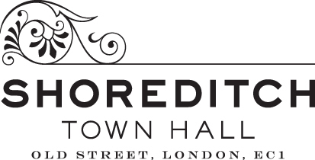
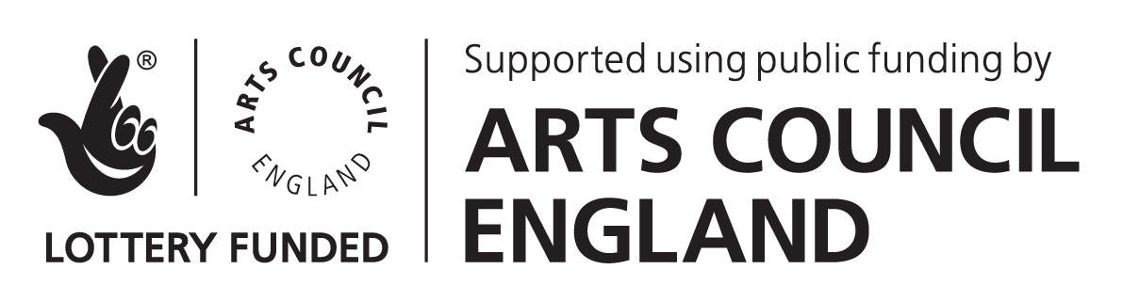
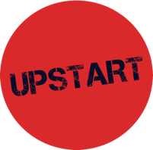
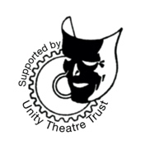
DARE FESTIVAL 5 COMMISSION GUIDANCE

INTRODUCTION
Upstart Theatre will commission up to 6 artists to create new, 30-minute in-development pieces of playable theatre or performance for DARE Festival 5, on the theme of ‘We Demand a Better Future’.
DARE Festival 5 will take place from Thursday 25th to Saturday 27th February 2021.
Application deadline: midday, Wednesday 2nd December.
Wednesday 18th November from 12-1pm Upstart Theatre will be hosting a live introduction to DARE Festival 5 over Zoom, with a chance to ask questions about the programme and application process. You can sign up here. The recording of this session will also be available online after the event.
Upstart Theatre is an arts charity based in London that invites people to reimagine the world by making theatre playable. You can read more about Upstart Theatre’s work on our website: www.upstart-theatre.co.uk.
ABOUT DARE FESTIVAL
DARE is a festival of new playable theatre and performance, exploring the borders between theatre, politics and conversation. It’s produced and curated annually by Upstart Theatre, commissioned by Shoreditch Town Hall and supported by Arts Council England and Unity Theatre Trust. DARE Festival brings together theatre, installations and discussions to kickstart conversations between artists and audiences.

We do this by:
- presenting new theatre and performance at the earliest possible stage in its development;
- holding informal discussion events around the themes of the works being presented;
- creating a space in which artists and audiences can come together as members of a single community.
See what previous DARE artists have to say about the programme here.
And you can watch our video recaps of DARE Festivals 2 here and 3 here.
WHAT IS PLAYABLE THEATRE?
“Playable theatre is live performance that engages audiences through active, meaningful participation.” - Northwestern University
When we talk about playable theatre, we’re thinking of performance which breaks down the barriers between performer and audience, and that creates a space for the audience to have genuine agency. For us at Upstart, this often means incorporating into the structure of our shows elements that you might find in games – we think of the audience as players as well as spectators. It might mean constructing branching narratives that the audience get to choose together; making it possible for each audience member to navigate their own way through the show; or creating an improvised show based around the relationship between a performer and an audience member who takes on a role. As makers of playable theatre, we want our audiences to be able to affect the way the performance develops each night. As a result, each performance is a unique experience, created by the artist and the audience together.
WHAT ARE WE LOOKING FOR?
We’re looking for proposals that are:
- New. Shows that have been previously presented elsewhere, had significant development, or have received funding from a public funder, trust, foundation, venue or organisation are not eligible. If you have self-funded or crowdfunded development on your show, please speak to us before applying to check eligibility.
- Playable. Does the work have meaningful opportunities for an audience to interact with it? The possibilities for how your work is playable are endless, but this could include game theatre, intimate one-on-one performances, or perhaps even a show that uses digital technology to pair live and online audiences together.
- Related to the theme of ‘We Demand a Better Future’. Previous DARE Festival themes have included power and money, and the commissioned works within these have covered a broad range of topics, from the political to the personal. We’re not prescriptive, and we’re excited to see lots of different interpretations of this theme.
- Early Stage. Given the commission level advertised, we’re keen to stress that we are looking for initial ideas that can be trialled and presented as an in-development version at DARE. The commission fee has been calculated to reflect this, and we anticipate that this will cover approximately two weeks of your time developing the show and presenting it at DARE Festival. We do not expect you to present the work with a complete production design. Similarly, if you already have a full production team in place, this probably isn’t the right opportunity for your show.
- Collaboratively made. The DARE programme is most suitable for work that is devised, either by a solo artist or as an ensemble. It’s not a script development programme, although you can have scripted elements in your work. DARE Artists attend three Artist Development Sessions where you are expected to share your work and support other artists with feedback.
- Possible to be realised within the commission fee. Presenting your show at DARE Festival should not be conditional on the need to secure extra funding, although you are welcome to seek out additional funds once commissioned if you would like to.
- Adaptable. The current situation with COVID-19 means that we have developed contingency plans to present DARE as a fully online festival if need be (more about this later in this pack). Artists will therefore need to think about ways in which their idea could be adapted to suit an online-only audience.
WHAT COMMISSIONED ARTISTS WILL RECEIVE
- A commission fee of £1,000 paid in one instalment on signature of contract.
- 3 socially distanced performance slots at DARE Festival 5, between 25-27 February 2021.
- 3 Artist Development Sessions with the other commissioned artists in January and February 2021 (two to be delivered on Zoom, one in-person).
- A fee of £50 per Artist Development Session attended per commissioned project (other artists than the Lead Artist are welcome to attend, but the fee will remain the same).
- Expert mentorship in creating playable work. Mentors will be selected after artists have been commissioned.
- Artistic support and guidance from Upstart Theatre’s Artistic Director, Tom Mansfield, with a minimum of 3 dedicated sessions throughout the programme.
- A minimum of two producing support and advice sessions with Producer Hannah Tookey on getting your show ready for DARE, as well as for your show’s future life, including fundraising, programming and building a team.
- A Stage Manager for your technical and dress rehearsals and all performances, who will help programme and operate your show.
- A minimum of 1 live-streamed performance of your show to an online audience.
- A recording of your show for you to keep and use for promotional purposes.
- Professional production photography of your show for you to keep and use for promotional purposes.
- Captioning and BSL interpretation for at least one of your performances.
- Marketing of DARE Festival to audiences and industry. Please note that Upstart Theatre will market DARE Festival as a whole, as audiences purchases tickets for the festival itself, rather than individual shows.

- You will retain complete creative control of your work and 100% ownership of the intellectual property rights. We ask you to acknowledge Upstart Theatre’s support for your work (see ‘Artist Commitments’ below).
WHERE AND HOW WILL IT TAKE PLACE?
DARE Festival takes place annually in The Ditch at Shoreditch Town Hall. Usually this means that performances take place in the Rivington Room and Garden Studio, with the Long Room being used as the festival hub and bar.
Due to COVID-19, DARE 5 will look different to previous editions of the festival, but we’ll do our best to retain the vibrant festival feel as much as we can. Whilst we’ll work towards and endeavour to deliver an in-person festival, there is the possibility that DARE Festival 5 will need to move online.
In addition, it’s very likely that performances will not take place exclusively in The Ditch, but that we may use other performance spaces within Shoreditch Town Hall to allow for appropriate social distancing in the building. The exact spaces to be used will be decided once commissioning has been completed and may be subject to change to comply with government guidelines at the time. This also means that it may not be possible to alter the layout of each performance space between shows as much as we previously did.
Further to this, previous DARE Festivals have allowed audiences to purchase a festival ticket and then to make decisions shortly before performances begin about which show to see. With the need for social distancing and tracking of audiences, everyone who attends will be required to book a specific seat for one ‘pathway’ or block of shows.
We’ll work with all commissioned artists to deliver the festival and their work in the best and most suitable format that we can. Artists will need to remain aware of all possibilities for presenting their work at DARE and be willing to adapt their shows if need be. We’ll continue to review guidelines and will be update our plan in line with government recommendations and Shoreditch Town Hall’s COVID-19 safety measures. The commissioning fee and support offered to artists will remain the same regardless of what format the festival takes.
Our three scenarios for DARE Festival 5 are as follows:
PLAN A
All shows are presented live at Shoreditch Town Hall, with at least one performance per show also live-streamed to online audiences.
PLAN B
DARE becomes a fully online festival, and all performances are live-streamed to audiences at home from Shoreditch Town Hall.
PLAN C
If artists are not able to travel to Shoreditch Town Hall due to restrictions, we’ll work with you to live-stream from a location near to you.
KEY DATES
Wednesday 4th November 2020 | Applications open
Midday, Wednesday 2nd December | Deadline for applications
Wednesday 9th December | All artists notified of whether they have been shortlisted or not.
Monday 14th and Tuesday 15th December | Shortlist interviews
Wednesday 16th December | Commissions offered to selected artists
Wednesday 6th January 2021 | Deadline for commissioning contracts to be signed. Commission fees paid to artist on receipt of signed contracts and invoices.
Saturday 9th January | Artist Development Session 1 (via Zoom)
Saturday 30th January | Artist Development Session 2 (via Zoom)
Saturday 13th February | Artist Development Session 3 / Playtest Day (at Shoreditch Town Hall)
Tuesday 23rd - Friday 26th February | Technical and dress rehearsals
Thursday 25th - Saturday 27th February | DARE Festival 5
ARTIST COMMITMENTS
- Whilst Upstart Theatre will provide some production support, you‘ll be responsible for managing your own budget and producing your show.
- To present three in-development performances of your commissioned show at DARE Festival 5.
- Commissioned artists (or the Lead Artist if applying as a collective), will need to attend all three Artist Development Sessions. Artists who attend these sessions must be those that can share and make decisions about the work in development.
- To provide marketing copy and an image that represents your show for the purposes of marketing DARE Festival.
- To take part in evaluation of the DARE programme, including surveys, discussions with the festival team, and video or audio recordings if applicable.
- To acknowledge Upstart Theatre’s support. All artists retain creative control and intellectual property rights to the work they create for DARE Festival 5. You will be required to credit any future iterations of the work with ‘Originally commissioned by Upstart Theatre for DARE Festival’.
WHO CAN APPLY & RESERVED COMMISSIONS
All artists commissioned for DARE Festival must have the right to work in the UK.
You may be based anywhere in the UK, and support with travel expenses will be discussed with commissioned artists if needed.
Upstart Theatre is committed to tackling barriers to progression in the arts, and to building an artist development programme that represents the diversity of UK. As such, four out of six of our commissions will be reserved for artists who are underrepresented in the arts:
- one commission for working, under, or benefit class artists;
- one commission for LGBTQ+ artists;
- one commission for artists of colour or who are from a minority ethnic background;
- one commission for artists who are disabled and / or whose day-to-day activities are limited by a long-term health condition or illness.
HOW TO APPLY
Application Form
Applications for DARE Festival must be submitted via this Google Form. Answers to the application questions may be submitted in a written, video or audio format. A word document with the application questions can be downloaded from our website to prepare your answers offline.
We would like to stress that we’re not expecting artists to spend a long time preparing their applications. DARE is about the development of new work and exciting ideas for playable theatre, and as such, we’re looking for potential first and foremost, and are not expecting fully-formed explanations of how your show will work or the mechanics that make it playable - that’s what the development process is for.
Our suggested word limits are a rough guide. We haven’t included word limits in the form in order to save applicants the time spent cutting out just a few words to fit the box. It’s okay if your answer is under or a little over, but please don’t exceed this excessively.
Shortlisting
We’ll aim to shortlist around 12 applications. We’ll ensure that our shortlist of applicants includes proportional representation in relation to our reserved commissions. Shortlisted artists will be invited to a 30-minute Zoom interview with Artistic Director Tom Mansfield and Producer Hannah Tookey. The interview questions will be sent to all shortlisted artists in advance to allow you to prepare.
How your application will be assessed
Your application will be read by Upstart Theatre’s team, which includes Artistic Director Tom Mansfield, Executive Producer Emma Sampson and Producer Hannah Tookey. The full panel will have completed Implicit Bias tests and will be following guidelines recommended by BIFA for taking unconscious bias into account when assessing applications. Equality and monitoring information will be separated from your application before it is assessed, although it may be used at the final commissioning stage to ensure that we are accurately allocating our reserved commissions.
Your application will be judged in relation to the criteria listed in the ‘What are we looking for?’ section above and will be rated for each of these on a sliding scale.
Feedback will be provided to all applicants if requested, whether or not you are shortlisted.
QUESTIONS & FURTHER INFORMATION
If you’d like to know more about DARE Festival or have questions about applying, the development process, or access requirements, please contact Producer Hannah Tookey at hannah.tookey@upstart-theatre.co.uk.

